 |  | The Institute for  Bioinformatics and  Evolutionary Studies |  |  | 
Genomics Resources Core Facility
Standard Operating Procedure

TITLE:
Dual Barcoded Two-Step PCR procedure for amplicon sequencing for Illumina
AUTHOR (S): |  |  | REVIEWER (S):
Suresh Iyer (208.885.7023) |  |  | Dan New, Matt Settles
SOP # | REVISION #: |  | DATE: | NUMBER OF PAGES:
GRC_007 | 6 (Dan New) |  | January 2014 (Dan New) | 9

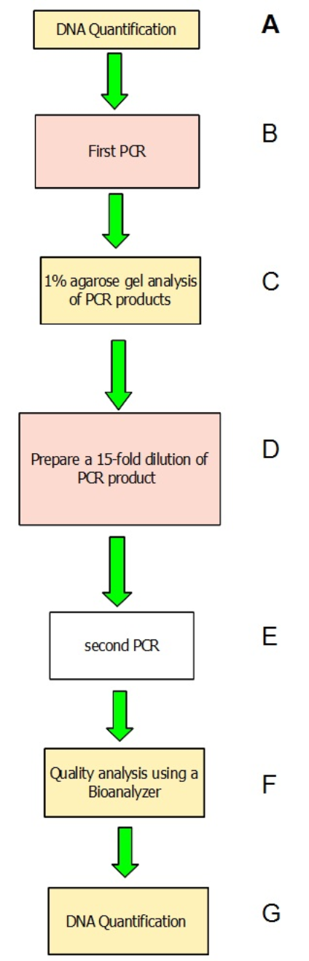
- PURPOSE

This document describes the method for performing dual-barcoding via a two-step PCR process for amplicons. The first PCR step isolates the target specific region whereas the second PCR step adds on Illumina adapters and barcodes. Both PCR primers of the first PCR include universal CS1 and CS2 tags. The second PCR extends the universal sequences with adapters and barcodes. These allow for maximum flexibility in target specific primer usage and the ability to separately barcode or include multiple targets in the same sequencing reaction without needing to purchase a large number of barcoded primers. Barcodes are included in both adapters currently allowing for 24x24 adapters to uniquely identify 576 samples. Fig 1 shows a chart of the procedure.

Fig 1.

Fig 2. The procedure for the two-step PCR

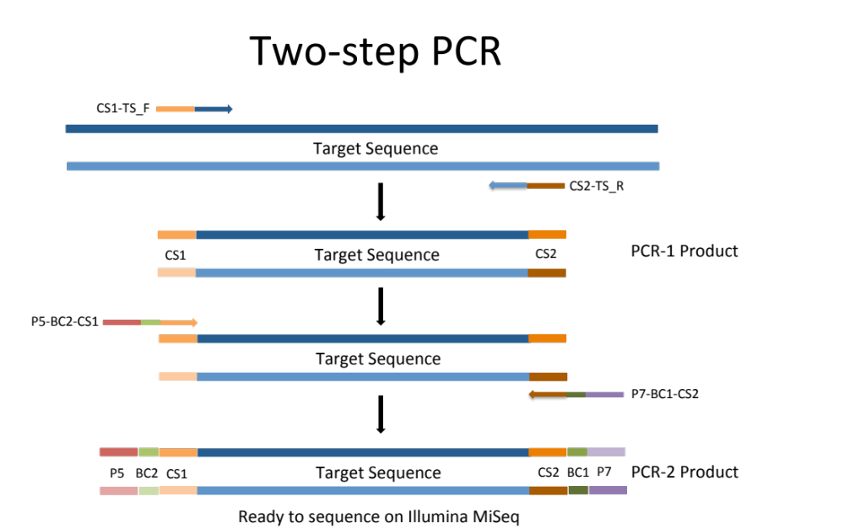

2. MATERIALS REQUIRED

- Agilent Bioanalyzer 2100 (Agilent Technologies, Cat no. G2940CA)
- DNA 1000 Kit (Agilent Technologies #5067-1504)
- PCR grade water, nuclease-free water
- Quant-IT Picogreen dsDNA Assay kit (Invitrogen, Cat# P7589)
-TBS-380 (now QuantiFluor™-ST fluorometer, Promega) or equivalent, or Nanodrop 2000
spectrophotometer (Fisher Scientific #ND-2000)
- 96-well plate reader (Molecular Devices, SPECTRA max GEMINI XPS)
- 96-well plates and adhesive sealing for 96-well plates
- 96-well black plates (Greiner bio-one, FIA-Plate Black 96 well, flat bottom, med binding)
- Horizontal gel apparatus (e.g. VWR, Cat no. 89032-290, 89032-288)
- UV transilluminator (e.g. VWR, Cat no. 89131-446)
- Thermocycler (e.g. Applied Biosystems, Cat no. 4314445 and N8050200)
- Ethidium Bromide solution (10mg/ml stock concentration) or GelRed Nucleic Acid Stain
(Phenix Research Products, cat#RGB-4103)
- 100bp DNA ladder (Phenix Research Products cat# DNAL-100bp)
- 10x PCR Buffer (NEB cat#B9014S)
- 25mM MgCl₂ (NEB cat# B9021S)
- BSA 20mg/ml (Fermentas cat#B14)
- 10mM dNTP mix (Fermentas cat#R0192)
- Taq DNA polymerase 5000U/ml (NEB cat#M0273S)

3. GENERAL LAB CONSIDERATIONS
- Work with amplicons must be done on designated bench only, away from laboratory areas where genomic DNA or all other PCR work is generally done.
- Gloves must be worn at all times during the work.
- Work must be done carefully to minimize the risk of aerosols.
- Eating or drinking is prohibited in the lab.

4. QUALITY CONTROL PROCEDURES
- Decontaminate all surfaces with 70% ethanol, before and after use.
- Use only pre-packaged aerosol-resistant pipette tips to minimize contamination of pipette shaft.
- Discard the pipette tips after each use to avoid cross-contamination.
- Gloves must be changed frequently, and especially between sample pools, to avoid cross-contamination.
- The pipettes used need to be calibrated annually.

5. SAFETY CONSIDERATIONS
- Wear UV protective glasses and gloves during exposure of gels to the UV transilluminator.
- Always have a waste disposable container.
- If ethidium bromide is used to visualize DNA in agarose gels, be aware that ethidium bromide is a potent mutagen. Take proper precaution while handling the solution. Handle only with gloves. Dispose off the ethidium bromide solution properly.
- Make sure to dispose ethidium bromide- containing gels in proper biohazard trash containers.
- Try to use an environmentally safe fluorescent nucleic acid dye, like GelRed Nucleic Acid Gel Stain, to replace the highly toxic Ethidium Bromide to stain DNA in gels.

6. PROCEDURE

A. DNA Quantification
First quantify template, preferably using a picogreen assay with a fluorometer or alternatively quantify with a nanodrop. Use 100ng of DNA for the first PCR reaction. 100ng of a bacterial isolate was used to produce the amplicons seen in this SOP. The amount of DNA to add will vary by sample so start with 100ng as a minimum amount and if that is insufficient add more DNA, or if absolutely necessary, use more cycles during the first PCR.

B. Prepare a reaction mix for PCR1 by combining the following components:
--------------------------------------------------------------------------------------------------------------
Reagents volume final concentration
--------------------------------------------------------------------------------------------------------------
10x PCR Buffer (NEB cat#B9014S) = 5µl 1x
25mM MgCl₂ (NEB cat# B9021S) = 6µl 3mM
BSA 20mg/ml (Fermentas cat#B14) = 0.6µl 0.24mg/ml
10mM dNTP mix (Fermentas cat#R0192) = 1µl 200µM
10µM TS-CS1 forward primer = 0.25µl 50nM
10µM TS-CS2 reverse primer = 0.25µl 50nM
Taq DNA polymerase 5000U/ml (NEB cat#M0273S) = 0.25µl 0.025U/µl
Nuclease-free PCR grade water = 35.65µl
Template DNA = 1.0µl 2ng/µl
--------------------------------------------------------------------------------------------------------------
Total reaction volume = 50µl
--------------------------------------------------------------------------------------------------------------
Cycling Protocol 95ºC 2 min
-----------------
20 cycles of
95ºC 1 min
51ºC 1 min
68ºC 1 min
-----------------
68ºC 10 min
10ºC ∞

C. 1% agarose gel analysis of PCR products
Run 5µl of the PCR product on a 1% agarose gel. Use ethidium bromide or Gel Red (see Materials section) to stain and view on a UV transilluminator. See Fig 3 for an example gel image. PCR was performed as described above and stained with Gel Red. A 100p DNA size marker was run alongside the samples. The intense DNA ladder band near the amplicon is 500bp. The amplicons themselves are ~620bp.

IMPORTANT NOTE:
We used NEB and Fermentas components were for both PCR reactions. As such, denaturation/extension times and temperatures are specific to these components. It is possible to obtain similar results with components from other companies but this will probably require some optimization. The goal is to produce amplicons containing minimal primer-dimers and a good yield of amplicon all with the fewest cycles of PCR possible. This can be helped by minimizing starting primer concentration and consuming most of the primer in the PCR reaction. You can also increase yield scaling up either PCR reaction (Vf of 50µl for example is standard in this protocol). Conversely if you have no problem with your PCR reactions you can scale down your reaction-volume to lower your per-sample cost. In the end please remember that clean PCR products of the correct size are critical for use in the second PCR reaction and therefore impact the quality of the data and/or success of the project.

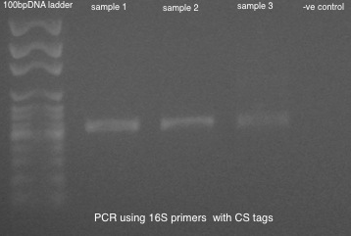
Fig 3.

STOP POINT
PCR products can be stored at 4ºC for up to 3 days or at -20ºC for longer periods.

D. Prepare a 15-fold dilution of the PCR products
Prepare a 15-fold dilution of the PCR product from first PCR step, as follows. In a 1.5ml tube add 2µl of product from first PCR to 28µl of PCR grade water. Vortex well to mix, then centrifuge briefly for 30 seconds to spin down all components. The 1:15 dilute PCR1 product is now ready to be used as template for PCR2 below.

E. Prepare a reaction mix for PCR2 by combining the following components:
--------------------------------------------------------------------------------------------------------------
Reagents volume final concentration
--------------------------------------------------------------------------------------------------------------
10x PCR Buffer (NEB cat#B9014S) =2µl 1x
25mM MgCl₂ (NEB cat# B9021S) =3.6µl 4.5mM
BSA 20mg/ml (Fermentas cat#B14) =0.6µl 0.24mg/ml
10mM dNTP mix (Fermentas cat#R0192) =0.4µl 200µM
2µM BC primer =0.75µl 75nM
Taq DNA polymerase 5000U/ml (NEB cat#M0273S) =0.20µl 0.050U/µl
Nuclease-free PCR grade water =11.45µl
Template DNA (PCR1 product) =1.0µl 1:300 (product1)
--------------------------------------------------------------------------------------------------------------
Total reaction volume =20µl
--------------------------------------------------------------------------------------------------------------
Cycling Protocol 95ºC 1min
-----------------
10 cycles of
95ºC 30 sec
60ºC 30 sec
68ºC 1 min
-----------------
68ºC 5 min
10ºC ∞

F. Quality analysis of PCR products using a Bioanalyzer
Check 1µl of the PCR product on the Agilent Bioanalyzer (BA) using the Agilent DNA 1000 kit. Follow the Agilent DNA 1000 kit Guide for details. You can also use another type of high-resolution imaging method as this is most desirable. If high-resolution imaging is not available or practical, a quality gel-image will be sufficient to judge PCR 2 product quality.

Typical Bioanalyzer traces after the second PCR are shown below. These BA traces show that when excess concentrations of primers are used large amounts of primer-dimers are present in the PCR product (A, B). A negative control (C) is shown with these high primer concentrations. The peak seen next to the lower marker (at 15bp) is a peak of primer dimers. The optimal primer concentration to use is shown in Fig 4D. The upper marker is 1500bp. Please note that use of 75nM or lesser primer concentration in the second PCR reaction should substantially minimize the primer-dimers when compared to 100nM or higher primer concentrations (as seen in Fig 4A-C).

Fig 4.
A. B.
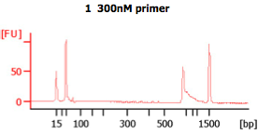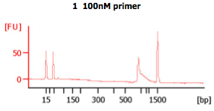
C. D.
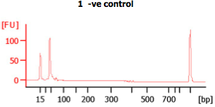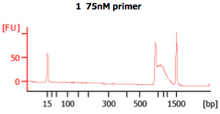
With whichever visualization method used, check the PCR product to determine if it is the expected size. The PCR products of the barcoding reaction (PCR2) should exhibit a band shift of ~69bp when compared to PCR1 products. This shift indicates the barcoded Illumina adaptors were added.

Store the PCR products at -20ºC.

G. PCR 2 product quantification
Quantify final PCR products if able. The IBEST Genomics Resources Core provides amplicon quantification as part of the amplicon preparation work-flow but with a large number of amplicons to quantify your per-sample cost will increase dramatically. We suggest quantifying yourself if you have a large number of amplicons.

H. Provide the IBEST GRC laboratory with the following:
- 100 ng of each amplicon product
- A high-resolution gel image from the second PCR. Please do not provide us laser printed images unless they are of high quality. Digital Images are best.
- Please see and follow the sample submission instructions to fully complete the sample submission sheet. If you do not have either please request copies.

